**AJAX**

AJAX (Asynchronous Javascript And XML) has become an indispensable component for Web Developers over the days. The power of AJAX is witnessed by its use in all the top websites like Google, Facebook, Yahoo, Bing, etc.

AJAX is an implementation of various interrelated web development techniques used on the client side to create asynchronous web applications.  
**Terms to be defined**Client – The system/computer from which the data is sent for processing.  
Server – The system/computer which receives the data sent by the client for processing.

With the development of AJAX, data can be sent and received asynchronously (in the background) without disturbing the behaviour of the web page in which the user is in.

The use of AJAX is often noticed in Google’s Instant Search Technique where you get the results the moment you start typing. Google does not refresh the page while doing this.

Here is the workflow:  
1) User starts typing the search term  
2) Google asynchronously sends the data to the server without affecting the page’s behaviour.  
3) Google’s server processes it and sends back a list of suggestions to the client (user)  
4) These results are again loaded using AJAX

  
Use of AJAX in Facebook for loading Newsfeeds:



One of the use of AJAX in Facebook can be witnessed when scrolling down to the bottom of the page after which the rest of the Newsfeeds load asynchronously.

AJAX makes use of Javascript and XML (Extensible Markup Language) as the name suggests but often uses even JSON (Javascript Object Notation) to perform its activities.

The AJAX flowchart is demonstrated in the below figure. (Reference: W3Schools)

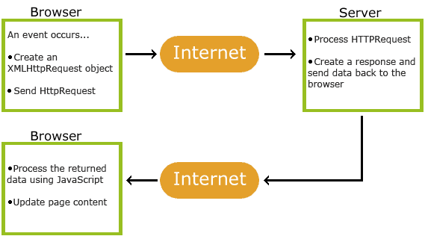

Here, XMLHttpRequest is an object generated by Javascript which enables the communication between client and server asynchronously. Microsoft created the XMLHTTP ActiveX control in Internet Explorer 5, which was later adopted by Mozilla, Safari, Opera and other browsers as the XMLHttpRequest JavaScript object.

**Advantages of using AJAX**1) Pages tend to load much faster than usual  
2) User need not navigate from page to page for seeing multiple content  
3) Used for autocomplete features as in Google  
4) Online Chatting is made easy using this feature.

**Drawbacks**1) Bookmarking of pages in pre-HTML5 based browsers is not possible when AJAX is used.   
Instead, Iframes are used.  
2) When using slow internet connections, use of AJAX might often disrupt user experience as in case of autocomplete features where a query is sent each time you press a key.  
3) It becomes difficult for search engines to index web pages as they do not execute Javascript codes.  
4) AJAX cannot be implemented in Javascript disabled browsers.

But still, the advantages of AJAX overweigh the disadvantages and it has been in implementation for many years and we can definitely claim that AJAX will play a major role in the future of web. If you are keen about learning AJAX, visit <http://www.w3schools.com/ajax/> for tutorials and references.